Hashing

Why hashing?
When we want to map some data(information) to a certain key, we use hashing. It is not always possible to use separate array for hashing, hence we use hashmaps.

Applications
- Play with element’s index
We have two options to do this:
- Traverse the whole array and access the element’s
For each element’s accessing, we have to incur O(n) time complexity.
- Map indices to their elements
This requires little extra memory, but optimizes the time complexity to O(1) {unordered_map} or O(log(n)) {ordered_map}.

Second option is better.

Another problem with option one
Storing indices of such large elements is not possible as we can declare only array of size 10⁸ (that too global).

Here is where hashing comes into picture

Hashing
Converting elements into smaller elements using special functions known as Hash functions.

Example: We have to map the following elements with their indices
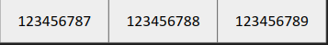
(0) (1) (2)
Let us consider a hash function
h(x) = x%10
After applying hash function on each element we get,

(0) (1) (2)

Key | Value
7 | 0
8 | 1
9 | 2

It might happen that while compressing elements, some keys result in the same values. This is called collision.

Collision Handling
The methods to solve this problem comes under collision handling. There are mainly two methods
- Separate Chaining
- Open Addressing

Separate Chaining
If a collision occurs, create a chain of values at the same key using a linked list.
Example
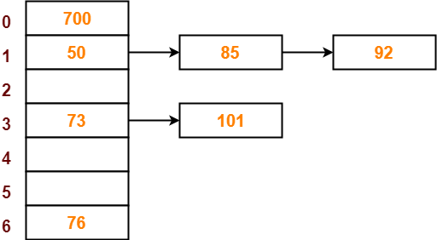
In the above example, a chain of values is being made at keys 1, 3.

Search Time Complexity: O(n)

Load Factor
Average amount of load at each key is called load factor.
Let the number of elements: n
Let the number of key on which values are to be mapped: b
Therefore the load factor of this combination is n/b.

Example:
In the given array, the number of keys on which we need to map the elements be 3.
Ans:
Number of elements = 6
Number of keys = 3
Load factor = 6/3 = 2.

Open Addressing
If a collision occurs, do probing.
Probing
In probing, we use a second argument probe number in the hash function. Probe number depends on the key, hence it is written as P(k).

There are three types of probing:
- Linear Probing:
Probe number is a linear function of key.
Example: P(k) = ak + b.
- Quadratic Probing
Probe number is a quadratic function of key.
Example: P(k) = ak² + bk + c.
- Double Hashing
In double hashing, we use a secondary hash function.
Example: P(k,x) = k*h₂(x), h₂(x) is a secondary hash function.

